**TASK 3**

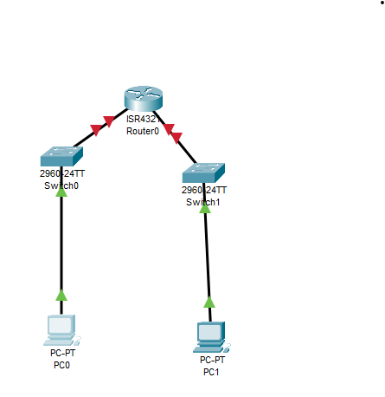

**Procedure:**

**Step 1: Setting Up the Network Topology**

1. **Open Cisco Packet Tracer.**
2. **Add devices:  
   ○ Drag and drop a Cisco switch (e.g., 2960) onto the workspace.  
   ○ Drag and drop two or more PCs onto the workspace.**
3. **Connect devices:  
   ○ Use the Connections option to select the Copper Straight-Through cable.  
   ○ Connect each PC to the switch using the FastEthernet ports (e.g., PC0 to FastEthernet0/1, PC1 to FastEthernet0/2).**

**Step 2: Configuring the Switch**

1. **Open the CLI (Command-Line Interface) of the switch:  
   ○ Click on the switch and go to the CLI tab.**

**Router Configuration Process**

1. **Enter privileged EXEC mode**
2. **Enter global configuration mode**
3. **Configure the switch hostname**
4. **Configure VLAN 1 (default VLAN) interface with an IP address**
5. **Save the configuration**

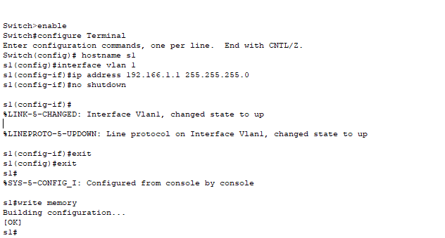

**Step 3: Configuring PCs**

1. **Assign IP addresses to PCs:  
   ○ Click on each PC and go to the Desktop tab.  
   ○ Open the IP Configuration and assign an IP address within the same subnet as the switch's VLAN 1 interface.**
   * **PC0: IP Address: 192.168.1.2, Subnet Mask: 255.255.255.0**

**Step 4: Testing Connectivity**

1. **Ping between PCs:  
   ○ Open the Command Prompt on one of the**

